2022 World Tai Chi & Qigong Day T-Shirts sign-up sheet
 | 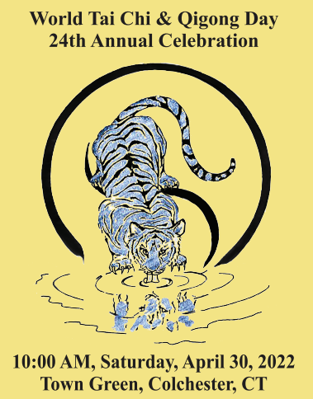 |  | 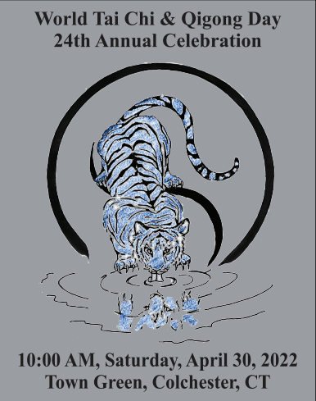
White | Yellow | Blue | Gray

Name | Phone | Color | Short  Sleeve $19  (Size) | Long Sleeve $24  (Size) | Size 2X & 3X add $3 | Total Paid

Ultra Cotton T-Shirts are 100% Cotton. Colors from Manufacturer’s website catalogue may not reproduce exactly as shown here. Shirts are available in long and short sleeve adult sizes - Small, Medium, Large, XLarge, XXL, and XXXL. Add $3 for each XXL or XXXL shirts.

